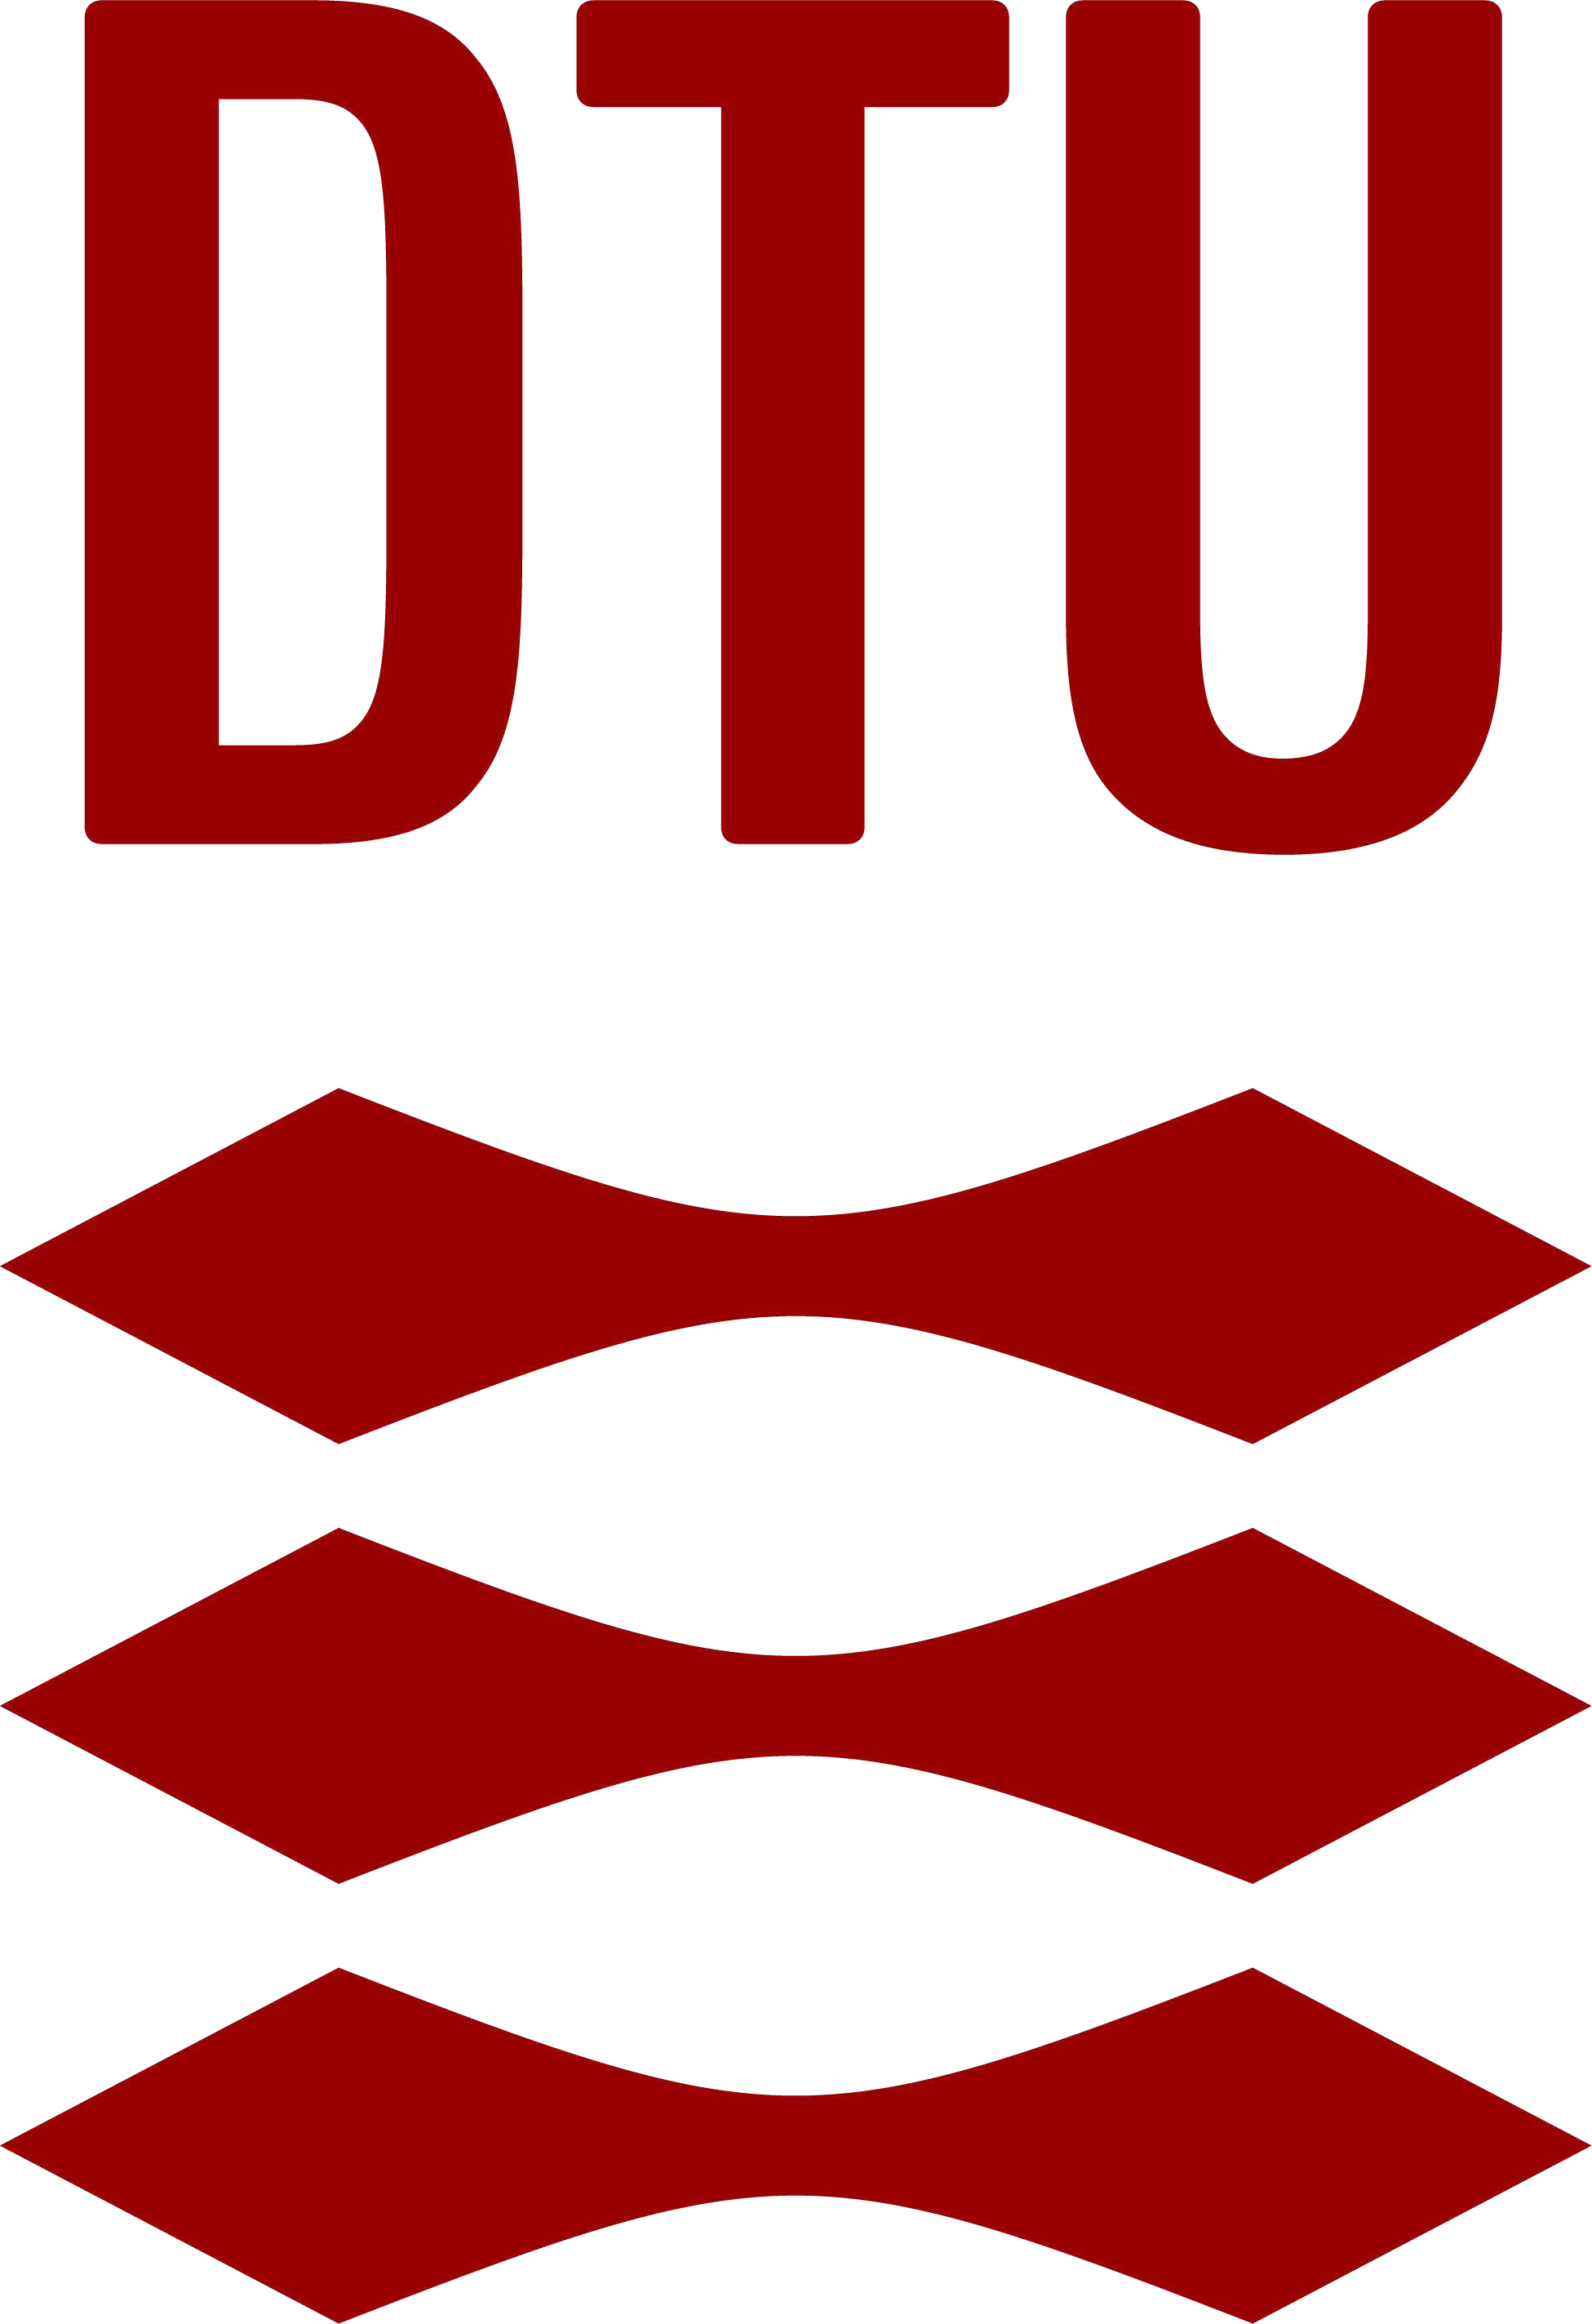

Application form

page 1

Please return the application form, with appendices, to:
EMBA Programme Director DTU Executive MBA

Building 421 Entrance C
Kollegiebakken
2800 Kgs. Lyngby

Applicant
First name:
Programme Director, Stig Andersen
Email: schhe@dtu.dk

Last name(s):
Home address:
ZIP code: City: Country: Telephone: Mobile:
E-mail:

Year of Birth:
English skills, on a scale of 1 to 5, where 5 =fluent: Written: Oral:

Education and training
Year: Program: Institution/Venue: Degree earned:

Career
Period: Company: Responsibilities: Position:

Leadership experience
Number of Years of Leadership Experience:

Application form page 2

Company Information
Company name:
Your job title in company:

Company address:

Central Business Reg. No.:
Tel. (switchboard): Direct line: E-mail:
Industry:

Company executive/sponsor
Who, if relevant, must recommend the participant (to be contacted by agreement with the applicant):
Name:

Job Title:
Address:
Tel. (switchboard): Direct line: E-mail:

Any additional information

Enclosures
Please enclose with your application a copy of your CV and an essay of not more
than three A4 pages and a recent picture of yourself.
› First of all tell us a bit about yourself; who you are when you are not at work.

› Secondly, write something about why you like to start the executive MBA and also why this is DTU's executive MBA.

› Thirdly, tell us how your view on leadership, what is leadership in your mindset and what is your own personal leadership style and how you want to develop your leadership.

› And fourthly send the key business challenges you - and your company are working with.
› The picture of yourself should be recent, a headshot (portrait) and good quality.

Your name as you actually use it:
Date
:
Applications will be processed as received. When we have received your application, you will be invited for an admission interview.

